You’re going to use the SOGWaM Simple Online Groundwater model to test the sensitivity of a model system to different parameters.
- To begin, open SOGWaM, which can be found at https://cjrusson.github.io/SOGWaM/.
  - Click to begin.
- First you will build a “base case model”
  - On the “Basic” tab:
    - Decide if you want your model to be cross sectional view or map view.
    - Choose a reasonable domain size and, if you are in map view, a reasonable grid thickness. This model is 2d, so that is the thickness of the unconfined aquifer.
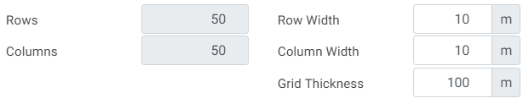
    - Choose a reasonable recharge rate (you will raise and lower this later, so choose a moderate value)
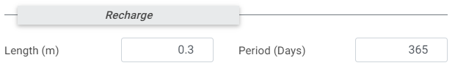
    - Choose “Sand” as a moderate soil type.
  - On the “Constant Heads” tab:
    - Add two constant head objects “objects” to generate flow in the domain.
    - Click simulate
    - Take a screenshot of the results, put this in a Word document as your “base case – no well” and give it a caption that describes the model.
  - On the “Wells” tab:
    - Add a well “Object” at a reasonable location with a reasonable pumping rate.
    - Click simulate
    - Take a screenshot of the results, put this in a Word document as your “base case”. Give it a caption that describes the model and draw a cartoon that shows what your model represents.
- Perform a sensitivity study on 3 parameters.
  - Each parameter should have two new simulations, in each of which the parameter is varied from your base-case model. Capture a screen shot of each new simulation and include them in your document.
  - The parameters you could vary include:
    - Basic Tab: Model thickness (if in map view), Recharge rate, Sediment type/heterogeneity
    - Constant Head Tab: Location/size/number of objects, Elevation(s)
    - Wells Tab: Location/number of wells, Pumping rate(s), Extraction/injection
  - Each sensitivity study should have at least three images (the base case and two additional) and should include a short caption describing the effect of varying that parameter on your model. Between the images and the caption I should be able to understand what you did and what it tells you.
  - Example sensitivity study:
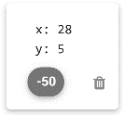 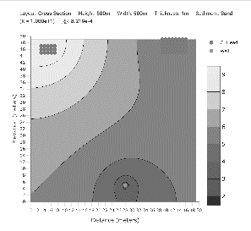, 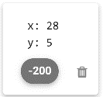 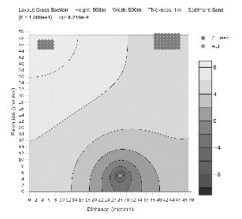,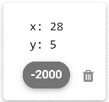 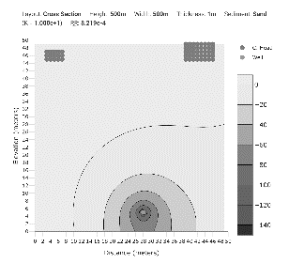
Example caption: Changing pumping rate increases the cone of depression and causes flow between rivers to change to flow from rivers to well.

